

Natalia Büttner

18171

*Evaluate and communicate business requirements*

|  |  |  |  |
| --- | --- | --- | --- |
| Name of Student | Natalia Büttner | ID | 18171 |

**Assessment – Research and Questioning**

Contents

Instructions: 1

Business Scenario 1

Task 1: Determine support areas 2

Task 2: Identify stakeholders 2

Task 3: Develop support procedures 2

Task 4: Assign Support Personnel 2

Task 5: Short Answer Questions 3

Task 6: Multiple Choice Questions 3

Search Index 8

#### View My Web Support:

https://luthiienn.github.io/ecbr18171/

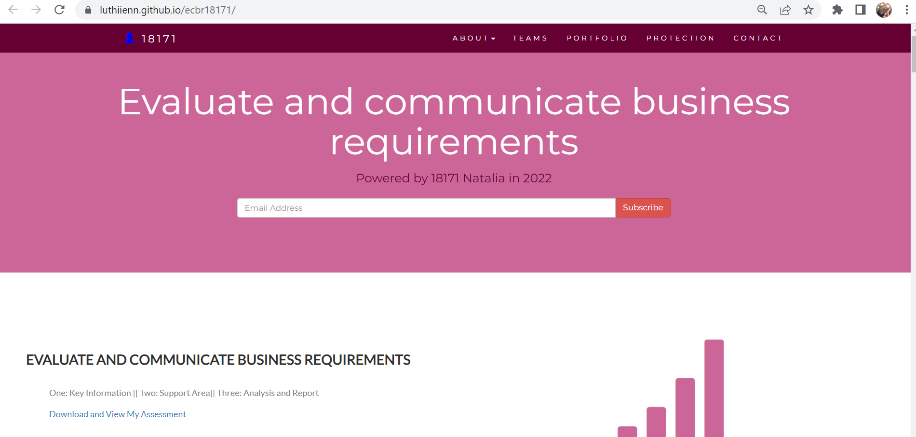

# Instructions:

This is an individual assessment. Answer all the questions on the document provided by your Trainer.

***Duration:***

Trainer will set the duration of the assessment.

# Business Scenario

D&K Books Pty Ltd is a bookstore owned by Mr. Dean Kerr. The business occupies two levels of an office building connected by escalators and lifts. D&K Books employs approximately six sales staff, one operation manager, two administrative officers, a bookkeeper and a marketing manager. They have an Ethernet network consisting of ten PCs (Intel I3 Desktop cloned), two switches, a router and three printers. They use the QuickBooks software to manage their entire business, including sales, inventory, ordering, accounts receivable, accounts payable, payroll and employee management. They also have two EFTPOS terminals one on each floor.

D&K Books has a Linux server that stores all of the data including the QuickBooks database. The server is backed up to tape regularly. They also have a website (hosted on an Australian ISP’s server, dynamic and static pages using asp.net) on which customers can browse the product catalogue and view current specials. They also lease a telephone system from Live Telecoms. The PABX (phone system) consists of a main switchboard and five remote phones with three incoming lines and a message-on-hold queue system.

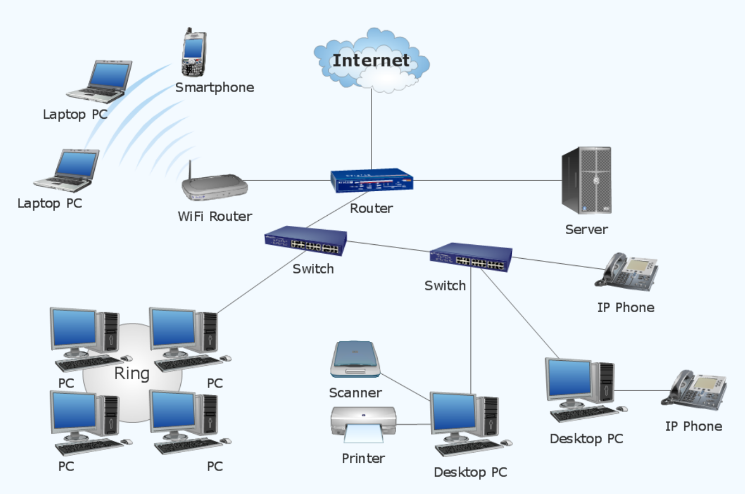

This is a general example, look below for case scenario.

|  |  |
| --- | --- |
| Hard ware | Software |
| Server X 1 | Linux server |
| Computer X 10 | Linux |
| Printer X 3 | SQL server |
| Remote phones X 5 | Telephone system |
| Modern X 2 | Website |
| Network Cable | Quickbooks software |
| EFTPOS machine |  |

# Task 1: Determine support areas

Identify information technology (HW and SW) and list the technology in use in D&K Books and consider the following:

* What sort of support does the technology require?
* Who is likely to provide this support?
* Does the support arrangement already exist?

Present your answer in a table such as the one below:

|  |  |  |  |  |
| --- | --- | --- | --- | --- |
| **Technology** | **Description** | **Support Required** | **Provider** | **Support Already exists? (Yes/No)** |
| QuickBooks Software | Software to manage their entire business, including sales, inventory, ordering, accounts receivable, accounts payable, payroll and employee management. | Training, customisation, tech support |  | Yes |
| PC’s | Intel I3 Desktop cloned | Maintenance and repair, update drivers, malware, and virus protection, fix any software problems | Electronic shop | No |
| Server | Linux with tape backup,  Stores all the data (including the QuickBooks database) | Troubleshooting,  Regular Maintenance,  Data Backup |  | No |
| EFTPOS | Card payment system, ‘Electronic Funds Transfer at Point Of Sale’,  Fast and secure | Link to bank account,  Settings (change name displayed on machine, etc) |  | Yes |
| Telephone system | PABX  Connects external and internal callers to an internal network via a switchboard,  Effortless call transferring,  Constant connectivity, independent from any phone service provider | Installations, repairments, new line or phone extension, upgrading software, setting changes | Live Telecoms | Yes |
| Website | Hosted on an Australian ISP’s server, dynamic and static pages using asp.net on which customers can browse the product catalogue and view current specials | Preparation of new web content (eg. text, graphics) | an Australian ISP’s server, dynamic and static pages using asp.net | Yes |
| Network | Computers linked to share resources, exchange files, or allow electronic communications.  Ethernet network consisting of ten PCs, two switches, a router and three printers | Diagnostics, troubleshooting, updates of antivirus, definitions, operating system upgrades, network connectivity and application patches |  | No |
| Printer |  | tech support | Brothers | Yes |

[*https://luthiienn.github.io/ecbr18171/#businessscenario*](https://luthiienn.github.io/ecbr18171/#businessscenario)

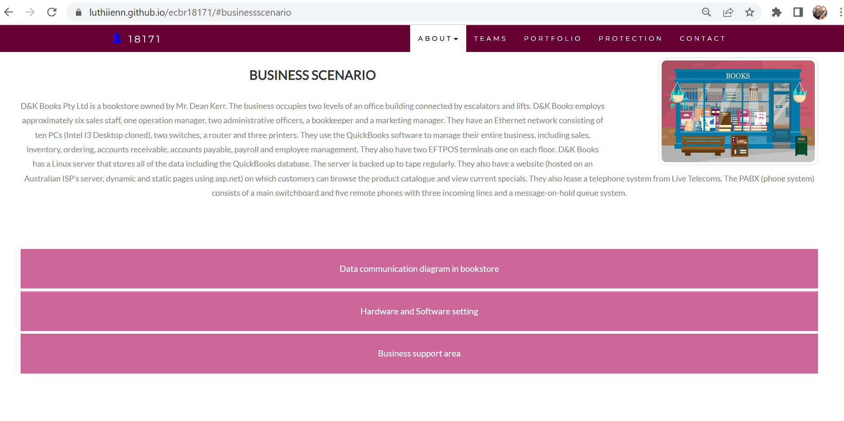

# Task 2: Identify stakeholders

Identify stakeholders related in D&K Books system

The stakeholders in this scenario are:

* Business Owner: Mr. Dean Kerr
* Staff: Operation Manager, Sales staff (x6), Administrative officers (x2), Bookkeeper and Marketing Manager
* External Stakeholders: Providers, Customers, suppliers.

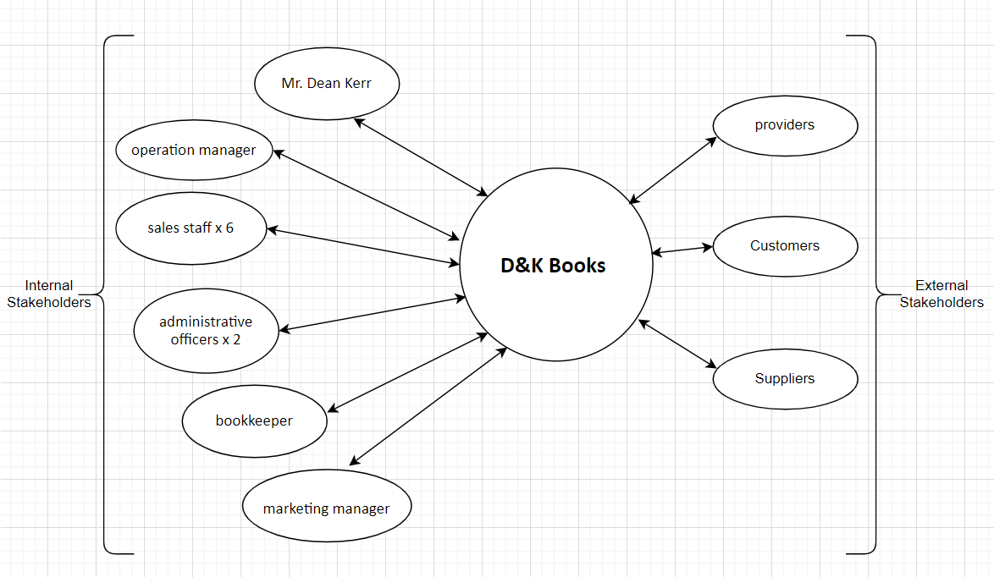

# Task 3: Develop support procedures

1. Describe one positive and one negative experience you have had when seeking assistance from a telecommunications company, an ISP or a computer supplier. Your experience may be via telephone, email or even voice recognition.

|  |  |  |
| --- | --- | --- |
| **Type** | **Positive** | **Negative** |
| Telephone | Easy to get an answer | You can’t send imagines, documents |
| Email | Document, Picture, words, or any media | Have to wait |
| Go to company | Face to face answer | Cost time and money on trip |
| Live chat | Speed, convenience, Solve your customers’ issues in real-time | May have Long Wait Times |
| Chatbot | Support 24/7 | Can’t solve complex issues |

1. Using the experiences described above please answer the following questions.
   1. What support aspects were professional and/or unprofessional?
   2. How long did the support process take?
   3. Were the steps logical?
   4. Did they solve your problem?
   5. Was the call deflected to another area?

Answer:

Case 1: a. I called an internet provider seeking assistance as the internet kept disconnecting every few minutes in the company I was working at. He was professional in a way as he was being polite, patient and taking time to explain so I could follow the steps. But on the other hand, when he needed to send me a picture while on the phone, he sent it through WhatsApp - an email with the picture would have been more professional but slower. b. The process took around 15 minutes. c. The steps were simple and logical. d. It solved the problem momentarily, the next day it started to happen again. e. The call wasn’t deflected as I had already chosen the technical support team option on the phone, and because the problem seemed to be solved at the time.

Case 2: a. I called the telecommunications company provider as the phone wasn’t working. The professional aspects were that he verified who he was talking to and he wouldn’t provide any information until I gave him the account number of the company. He was also professional by the way he was talking when explaining the steps to follow. b. The process took around 10 minutes. c. The steps were logical, we found the problem after checking a few things. d. It solved the problem and I learnt how to check and change some configuration issues. e. The call wasn’t deflected.

# Task 4: Assign Support Personnel

Classify the following into soft skills and technical skills. Your answer should take the form of a table shown below.

|  |  |  |
| --- | --- | --- |
| **Skill** | **Soft skill** | **Technical skill** |
| A knowledge of Linux |  | X |
| The ability to work under pressure | X |  |
| The administration of Windows 2008 Server |  | X |
| The ability to formulate network and IT policies |  | X |
| The ability to write network documentation | X |  |
| The ability to give presentations | X |  |
|  | | |

# Task 5: Short Answer Questions

1. Explain the relationship between data, information and knowledge.

When information is entered and stored in a computer, it is generally referred to as “data.”

After processing (such as formatting and printing), output data can again be perceived as

“information.” When information is packaged or used for understanding or doing

something, it is known as "knowledge".

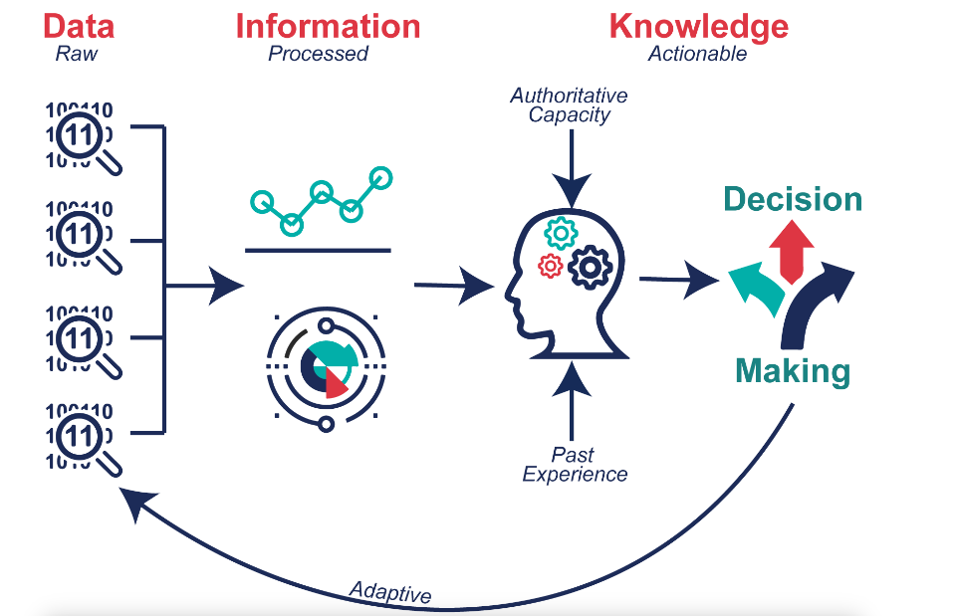

<https://internetofwater.org/valuing-data/what-are-data-information-and-knowledge/#:~:text=Data%20in%20their%20simplest%20form,Knowledge%20is%20what%20we%20know>.

1. What is quantitative data and how can you use it.

Quantitative data can be measured. Sources include reports for decision making, performance reports, data capture forms, and numeric results from surveys and statistical, research. Quantitative data can be analysed using mathematical equations and computation.

<https://www.fullstory.com/quantitative-data/>

<https://www.questionpro.com/blog/quantitative-data/>

1. What is qualitative data and how can you use it.

Qualitative data is a record of thoughts, observations, opinions or words. Qualitative data

often comes from asking open-ended questions to which the answers are not limited by a

set of choices or a scale. Qualitative data is important to capture; it may be in the form of

memos, procedure manuals, survey responses, workshop results or policy guidelines.

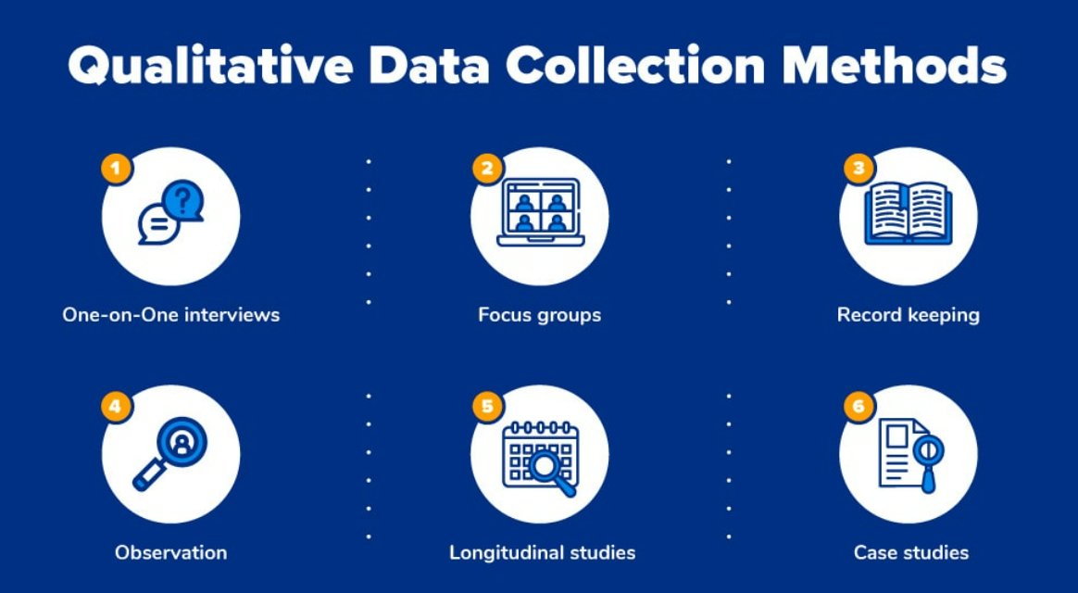

<https://www.questionpro.com/blog/qualitative-data/>

1. Give an example of how quantitative and qualitative data can be used in conjunction with each other

Example: Google Analytics + User Interviews

Google Analytics offers a wealth of quantitative data, such as how many people visited your site, how they got there, and how long they stayed. The information is incredibly helpful and extremely detailed, but without thoughtful interpretation, it’s useless.

In many cases, Google Analytics’ quantitative data will help you pinpoint exactly where your problem lies. But only qualitative data can identify the cause of the issue. Why is that text box causing people to leave your site? Is the field too difficult to fill out? You’ll obtain this information through interviews, co-browsing sessions or feedback tools.

<https://voccii.com/qualitative-and-quantitative-data#:~:text=Mixed%20Methods%3A%20Two%20Types%20of%20Research&text=Ways%20to%20gather%20quantitative%20data,opinions%2C%20values%2C%20and%20beliefs>.

1. What sort of methods could you use to determine client requirements for a website design and key information sources?

• Customer feedback

• Customer Questionnaires and surveys

• Customer support

• Customer service centre

• Do research

• Interviews and observation

• Brainstorming

• Use Cases & Scenarios

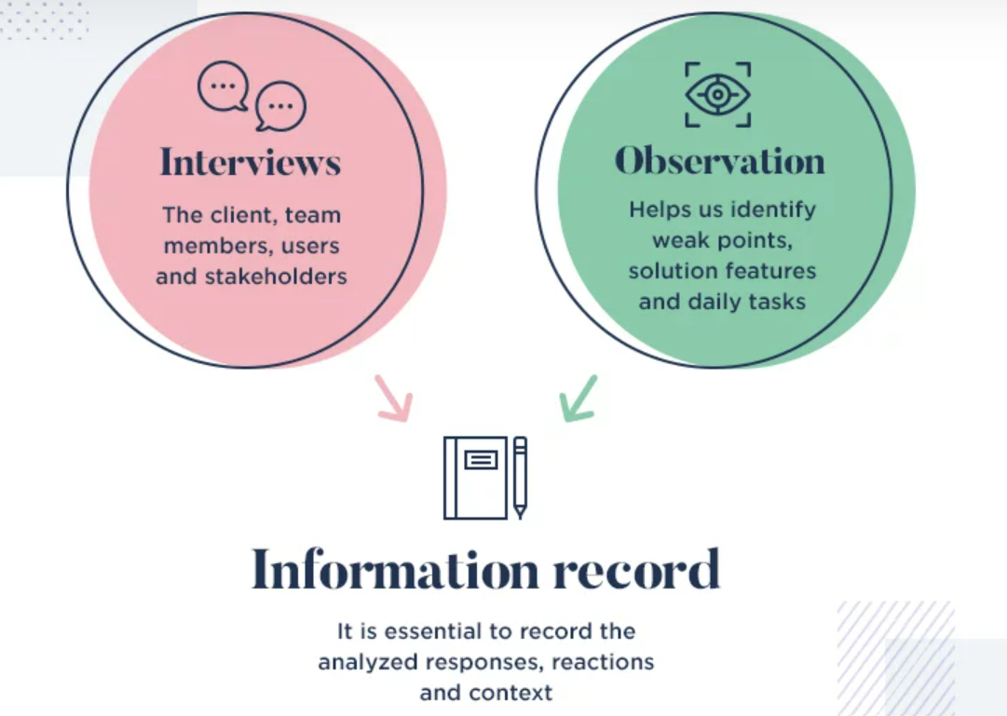

<https://www.justinmind.com/blog/gathering-requirements/>

1. Give some examples of client requirements for a website design

* Colour Scheme
* Fonts
* Website Content Requirements
* Images
* Mock-ups
* Text Content
* Logo

<https://www.primalspace.co.uk/client-requirements-website-design/>

* Budget
* For example, the client may require marketing materials such as business cards, brochures and letterhead.
* Create a logo from scratch
* Time frame

<https://marketingmedia.ca/web-design-checklist-what-clients-should-provide-their-web-agency/>

* Site Security
* Technology Requirements: What technology requirements (if any) does the new site have? For instance, should the site be developed on the Microsoft .Net platform, or .PHP? Do you need a printable version of the site? A mobile version?

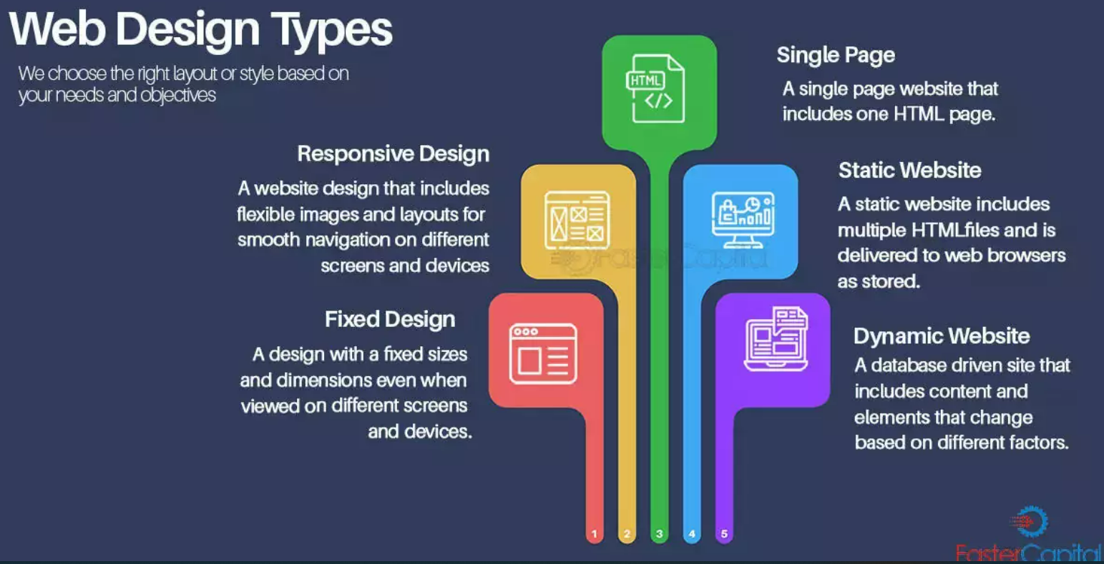

<https://fastercapital.com/technical-startup-web-design.html>

# Task 6: Multiple Choice Questions

1. Generally, how many points should a rating scale have?
   1. Five
   2. Four
   3. Ten
   4. Somewhere from 4 to 11 points

Users need choices. If there aren’t enough response options users will be forced to choose the next best alternative and this introduces measurement error. The psychometric literature suggests that having more scale points is better but there is a diminishing return after around 11 points (Nunnally 1978).

<https://measuringu.com/scale-points/#:~:text=The%20psychometric%20literature%20suggests%20that,maintain%20too%20many%20response%20options>.

Ordinal scales are shorter (usually 4, 5 or 6 points) and descriptive (each interval is labelled), therefore respondents have an easier time interpreting the scale and answering these types of questions.

Interval scales compared to ordinal is that the focus shifts from the labels to the numbers, as it's the numeric values that indicate the magnitude of difference. Interval scales tend to utilize larger ranges, such as a 10 or 11 point scale.

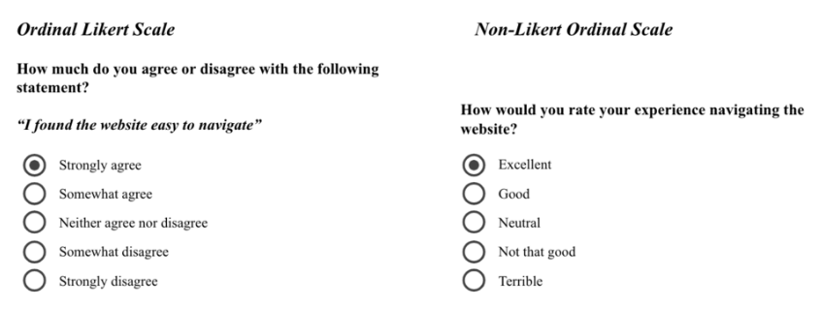

Interval scale:

<https://analythical.com/blog/types-of-rating-scales>

1. What is the problem(s) with this set of response categories to the question “What is your current age?” o 1-5 o 5-10 o 10-20 o 20-30 o 30-40
   1. The categories are not mutually exclusive
   2. The categories are not exhaustive
   3. Both a and b are problems
   4. There is no problem with the above set of response categories

The problems of this question are:

* The answers are not mutually exclusive: this means that if the person is 20 years old, option 3 and option 4 could be choose by them.
* The answers are not exhaustive: it doesn’t include people above 40 years old. They wouldn’t be able to answer this question.

1. You should mix methods in a way that provides complementary strengths and no overlapping weaknesses. This is known as the fundamental principle of mixed research.

a) True

b) False

This principle is important because it provides the researcher with a logic for mixing quantitative and qualitative research approaches. Mixing quantitative and qualitative approaches in a haphazard way will produce undesirable results.

Mixing should be systematic and well thought out by the researcher when planning and designing a research study.

Chapter 16: Mixed Researchhttps://edge.sagepub.com › sites › default › files

DOC

1. According to the text, questionnaires can address events and characteristics taking place when?
   1. In the past (retrospective questions)
   2. In the present (current time questions)
   3. In the future (prospective questions)
   4. All of the above

The process involved in these studies is almost the same, except for the fact that prospective studies are done before the outcome and retrospective survey is done after. <https://www.formpl.us/blog/retrospective-prospective-cohort-study>

Retrospective questionnaires allows you to capture what went wrong, what could have been done differently and suggestions for future projects. <https://www.typeform.com/templates/t/retrospective-survey-template/>

1. Which of the following are principles of questionnaire construction?
   1. Consider using multiple methods when measuring abstract constructs
   2. Use multiple items to measure abstract constructs
   3. Avoid double-barrelled questions
   4. All of the above
   5. e. Only b and c

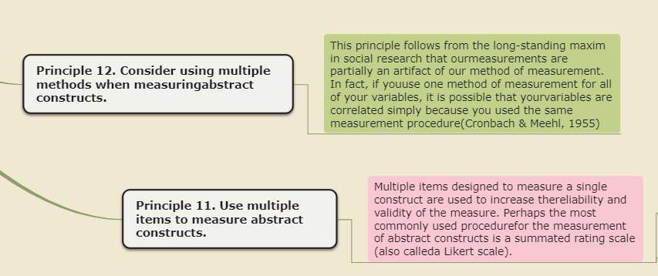

<https://www.mindomo.com/sv/mindmap/chapter-8-principles-of-questionnaire-construction-e8a69f6fa9b34accb4580a173227dd7c>

1. Which of these is not a method of data collection?
   1. Questionnaires
   2. Interviews
   3. Experiments
   4. Observations

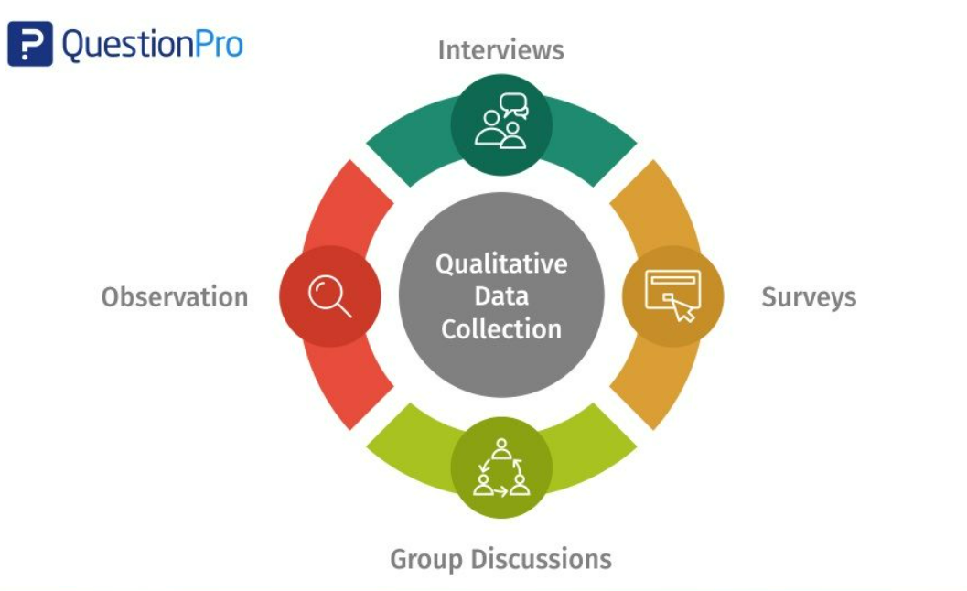

<https://www.questionpro.com/blog/qualitative-data-collection-methods/>

1. Secondary/existing data may include which of the following?
   1. Official documents
   2. Personal documents
   3. Archived research data
   4. All of the above

Secondary research, also known as desk research, is a research method that involves compiling existing data sourced from a variety of channels. This includes internal sources (e.g.in-house research) or, more commonly, external sources (such as government statistics, organisational bodies, and the internet).

<https://www.qualtrics.com/au/experience-management/research/secondary-research/?rid=ip&prevsite=en&newsite=au&geo=AU&geomatch=au>

1. An item that directs participants to different follow-up questions depending on their response is called a ____________.
   1. Response set
   2. Probe
   3. Semantic differential
   4. Contingency question

Contingency question – A question that is answered only if the respondent gives a particular response to a previous question. This avoids asking questions of people that do not apply to them (for example, asking men if they have ever been pregnant).

<https://en.wikipedia.org/wiki/Questionnaire_construction>

1. Which of the following terms best describes data that were originally collected at an earlier time by a different person for a different purpose?

a) Primary data

* 1. Secondary data
  2. Experimental data
  3. Field notes

Secondary data refers to data that is collected by someone other than the primary user. Common sources of secondary data for social science include censuses, information collected by government departments, organizational records and data that was originally collected for other research purposes.

Secondary data analysis can save time that would otherwise be spent collecting data and, particularly in the case of quantitative data, can provide larger and higher-quality databases that would be unfeasible for any individual researcher to collect on their own.

<https://en.wikipedia.org/wiki/Secondary_data>

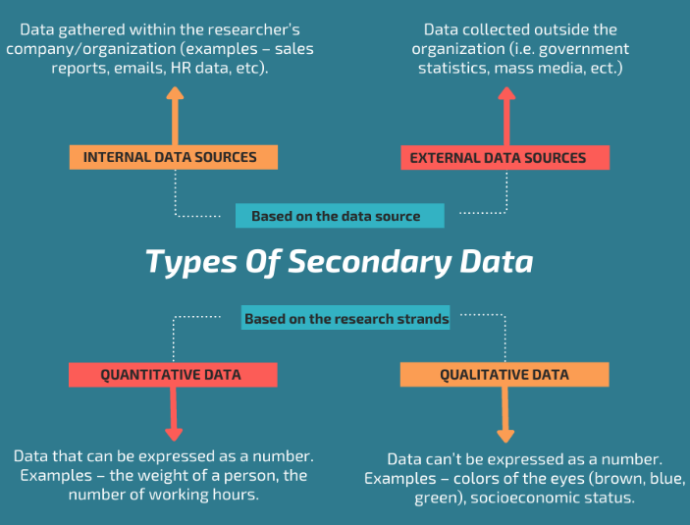

<https://www.intellspot.com/secondary-data/>

1. Researchers use both open-ended and closed-ended questions to collect data. Which of the following statements is true?
   1. Open-ended questions directly provide quantitative data based on the researcher’s predetermined response categories
   2. Closed-ended questions provide quantitative data in the participant’s own words
   3. Open-ended questions provide qualitative data in the participant’s own words
   4. Closed-ended questions directly provide qualitative data in the participants’ own words

Open-ended questions are questions that cannot be answered with a simple 'yes' or 'no', and instead require the respondent to elaborate on their points. Open-ended questions help you see things from a customer's perspective as you get feedback in their own words instead of stock answers.

<https://www.hotjar.com/blog/open-ended-questions/>

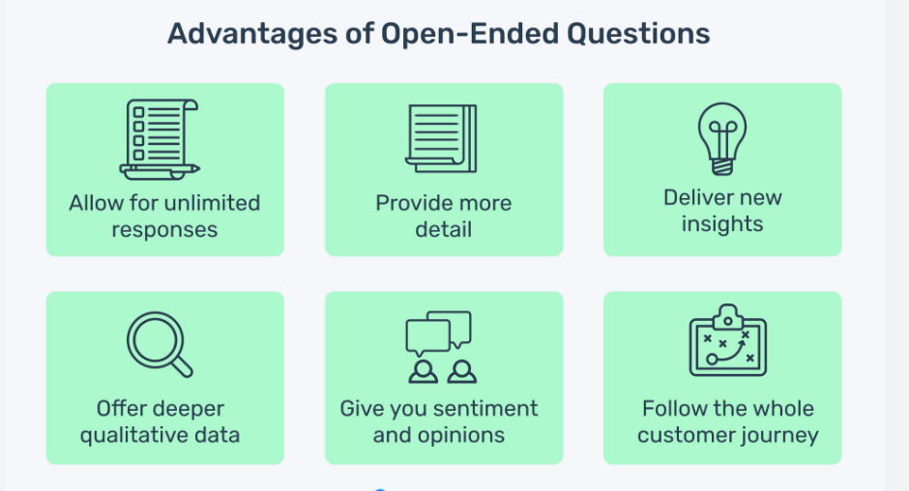

<https://monkeylearn.com/blog/advantages-of-open-ended-questions/>

1. Open-ended questions provide primarily ______ data.
   1. Confirmatory data
   2. Qualitative data
   3. Predictive data
   4. None of the above

Open-ended questions are used in qualitative research (see the video above for more information) and closed-ended questions are used in quantitative research.

Open-ended questions, and therefore without presumptions, can be used to see which aspect stands out from the answers and thus could be interpreted as a fact, behaviour, reaction, etc. typical to a defined panel of respondents.

<https://www.intotheminds.com/blog/en/qualitative-research-open-and-closed-ended-questions/>

1. Which of the following is true concerning observation?
   1. It takes less time than self-report approaches
   2. It costs less money than self-report approaches
   3. It is often not possible to determine exactly why the people behave as they do
   4. All of the above
2. Qualitative observation is usually done for exploratory purposes; it is also called ___________ observation.
   1. Structured
   2. Naturalistic
   3. Complete
   4. Probed

Naturalistic observation is a qualitative research method where you record the behaviors of your research subjects in real world settings. You avoid interfering with or influencing any variables in a naturalistic observation.

You can think of naturalistic observation as “people watching” with a purpose.

<https://www.scribbr.com/methodology/naturalistic-observation/#:~:text=Naturalistic%20observation%20is%20a%20qualitative,people%20watching%E2%80%9D%20with%20a%20purpose>.

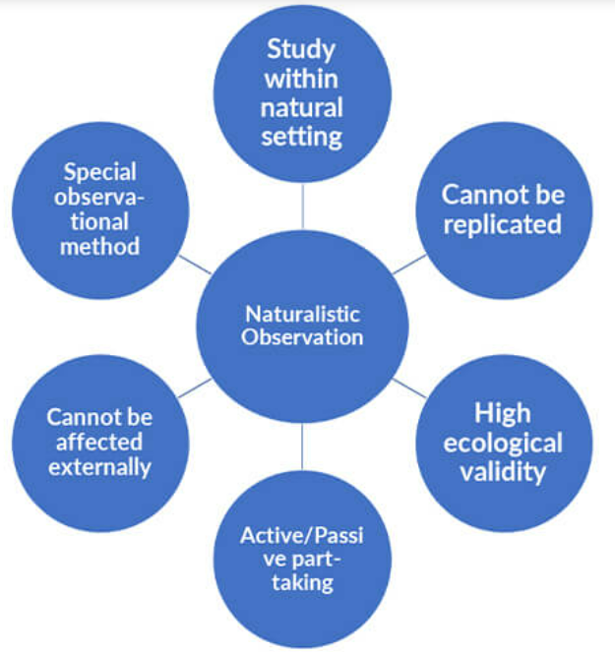

<https://www.bachelorprint.eu/methodology/naturalistic-observation/>

1. When constructing a questionnaire, it is important to do each of the following except ______.
   1. Use "leading" or "loaded" questions
   2. Use natural language
   3. Understand your research participants
   4. Pilot your test questionnaire

<https://www.mindomo.com/sv/mindmap/chapter-8-principles-of-questionnaire-construction-e8a69f6fa9b34accb4580a173227dd7c>

1. Another name for a Likert Scale is a(n):
   1. Interview protocol
   2. Event sampling
   3. Summated rating scale
   4. Ranking

Likert scaling is a bipolar scaling method, measuring either positive or negative response to a statement. Sometimes an even-point scale is used, where the middle option of "neither agree nor disagree" is not available. This is sometimes called a "forced choice" method, since the neutral option is removed. The neutral option can be seen as an easy option to take when a respondent is unsure, and so whether it is a true neutral option is questionable.

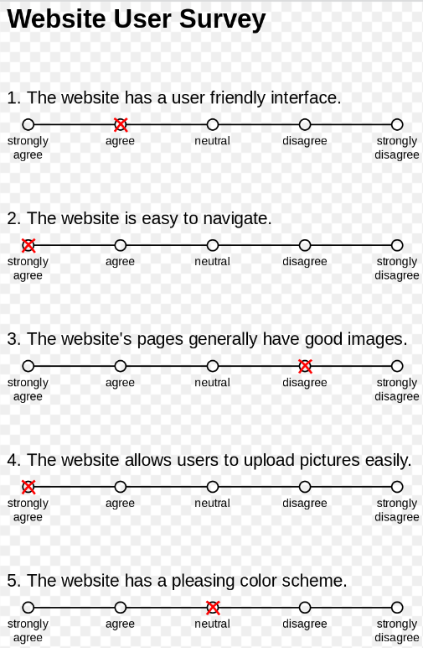

<https://en.wikipedia.org/wiki/Likert_scale>

1. Which of the following is not one of the six major methods of data collection that are used by educational researchers?
   1. Observation
   2. Interviews
   3. Questionnaires
   4. Checklists

Historically, much of the data collection performed in educational research depended on methods developed for studies in the field of psychology, a discipline which took what is termed a “quantitative” approach. This involves using instruments, scales, Tests, and structured observation and interviewing. By the mid- to late twentieth centuries, other disciplines such as anthropology and sociology began to influence educational researchers. Forms of data collection broadened to include what is now called “qualitative” methods, with an emphasis on narratives, participant perspectives, and less structured observation and interviewing.

<https://www.oxfordbibliographies.com/view/document/obo-9780199756810/obo-9780199756810-0087.xml>

1. The type of interview in which the specific topics are decided in advance but the sequence and wording can be modified during the interview is called:

a) The interview guide approach

* 1. The informal conversational interview
  2. A closed quantitative interview
  3. The standardized open-ended interview

The guide approach is intended to ensure that the same general areas of information are collected from each interviewee; this provides more focus than the conversational approach, but still allows a degree of freedom and adaptability in getting the information from the interviewee.

<https://www.public.asu.edu/~kroel/www500/Interview%20Fri.pdf>

1. Which one of the following in not a major method of data collection?
   1. Questionnaires
   2. Interviews
   3. Secondary data
   4. Focus groups
   5. All of the above are methods of data collection

1. A question during an interview such as “Why do you feel that way?” is known as

a) Probe

* 1. Filter question
  2. Response
  3. Pilot

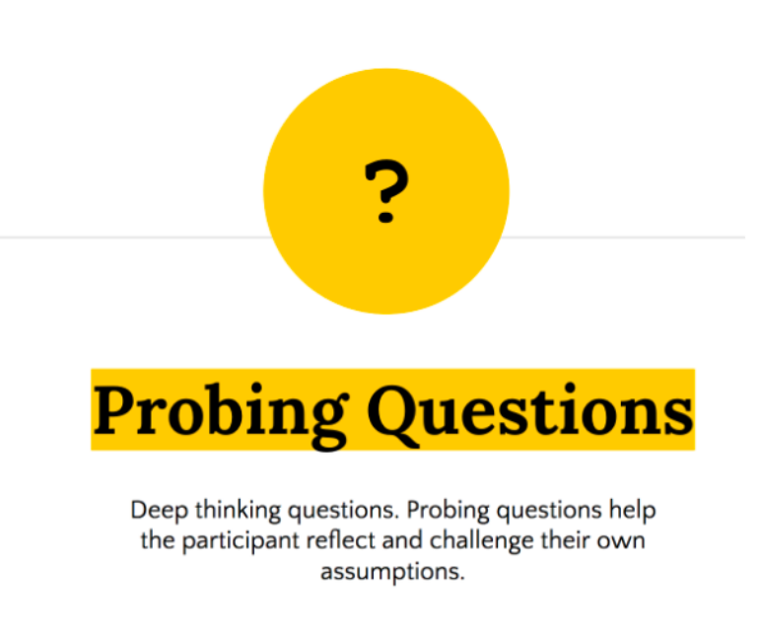

<https://globalonlineacademy.org/insights/articles/20-questions-that-promote-inquiry-based-learning>

1. A census taker often collects data through which of the following?
   1. Standardized tests
   2. Interviews
   3. Secondary data
   4. Observations
2. The researcher has secretly placed him or herself (as a member) in the group that is being studied. This researcher may be which of the following?

a) A complete participant

* 1. An observer-as-participant
  2. A participant-as-observer
  3. None of the above

1. Which of the following is not a major method of data collection?
   1. Questionnaires
   2. Focus groups
   3. Correlational method
   4. Secondary data

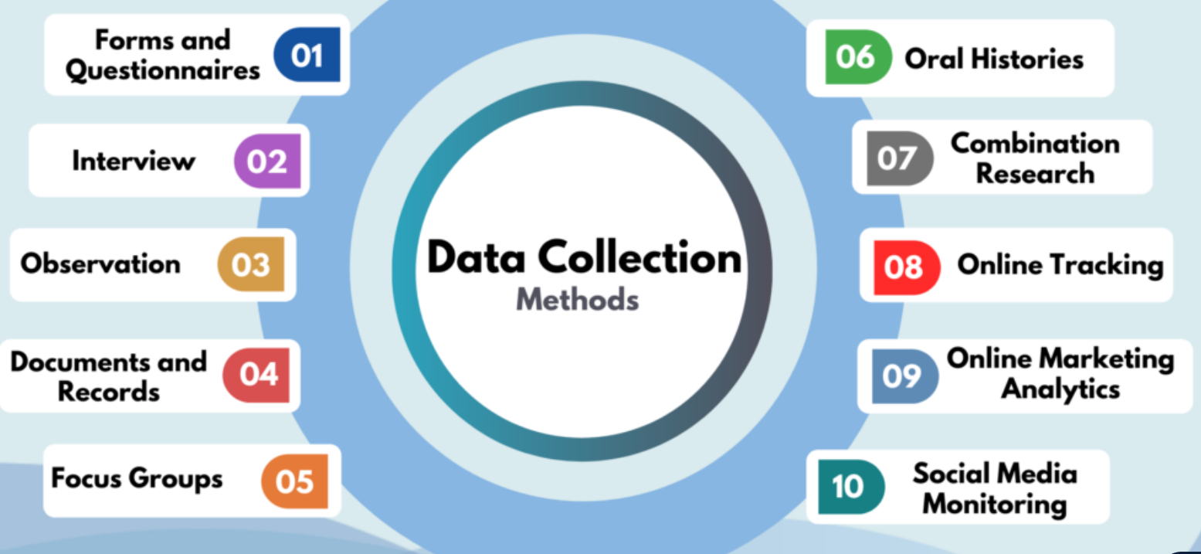

<https://www.globalpatron.com/blog/data-collection-methods/>

1. Which type of interview allows the questions to emerge from the immediate context or course of things?

a) Interview guide approach

* 1. Informal conversational interview
  2. Closed quantitative interview
  3. Standardized open-ended interview

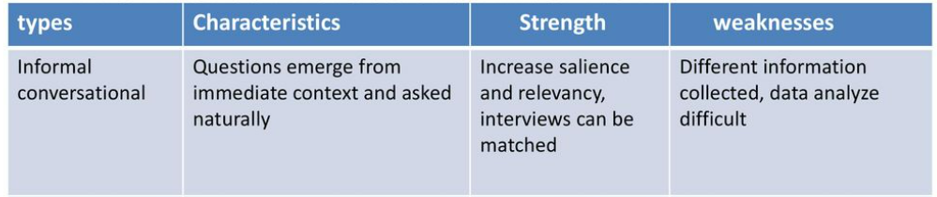

<https://slideplayer.com/slide/13534755/>

1. When conducting an interview, asking "Anything else? What do you mean? Why do you feel that way?," etc, are all forms of:
   1. Contingency questions
   2. Probes
   3. Protocols
   4. Response categories

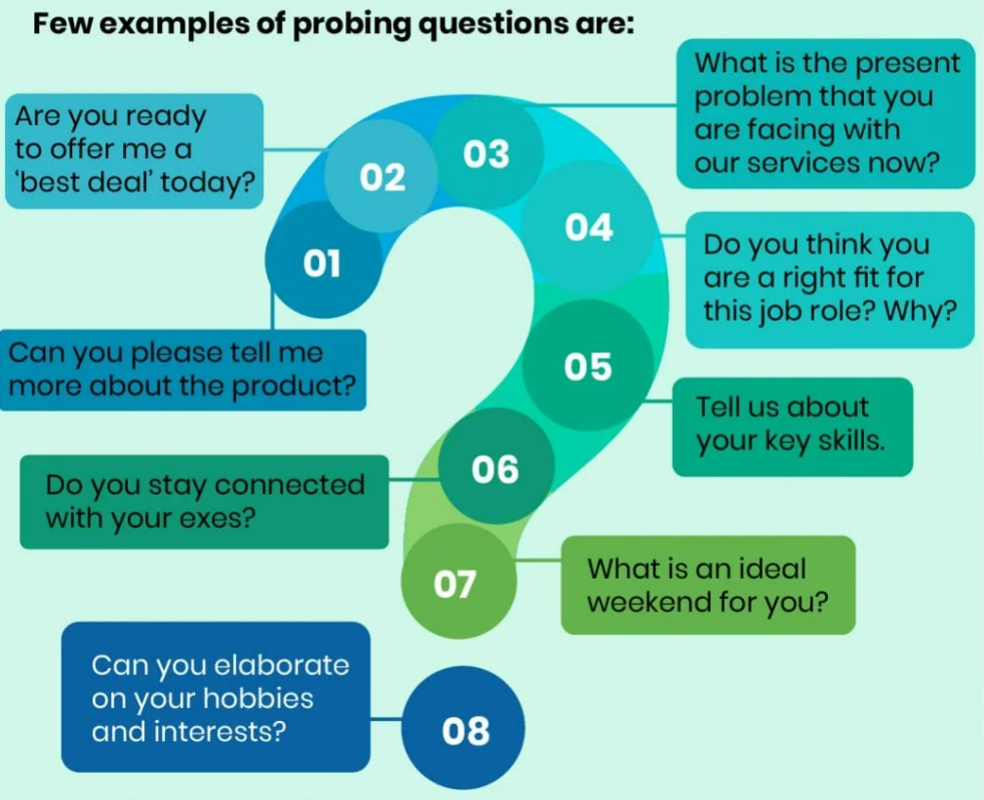

<https://themindfool.com/different-types-of-probing-questions/>

1. When constructing a questionnaire, there are 15 principles to which you should adhere. Which of the following is not one of those principles?
   1. Do not use "leading" or "loaded" questions
   2. Avoid double-barrelled questions
   3. Avoid double negatives
   4. Avoid using multiple items to measure a single construct

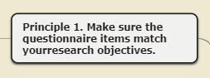

<https://www.mindomo.com/sv/mindmap/chapter-8-principles-of-questionnaire-construction-e8a69f6fa9b34accb4580a173227dd7c>

1. A customer-based Service Level Agreement structure includes:
   1. An SLA covering all Customer groups and all the services they use
   2. SLAs for each service that are Customer-focused and written in business language
   3. An SLA for each service type, covering all those Customer groups that use that Service
   4. An SLA with each individual Customer group, covering all of the services they use

Customer-based SLA:

With customer-based SLAs, the agreement revolves around a single customer.

For example, an e-commerce store signs an SLA with a manufacturer to create their t-shirts. The SLA stipulates the services provided by the manufacturer to the individual e-commerce store. The agreement includes things like the quality of materials, the number of shirts to be produced within a given time, and the delivery dates.

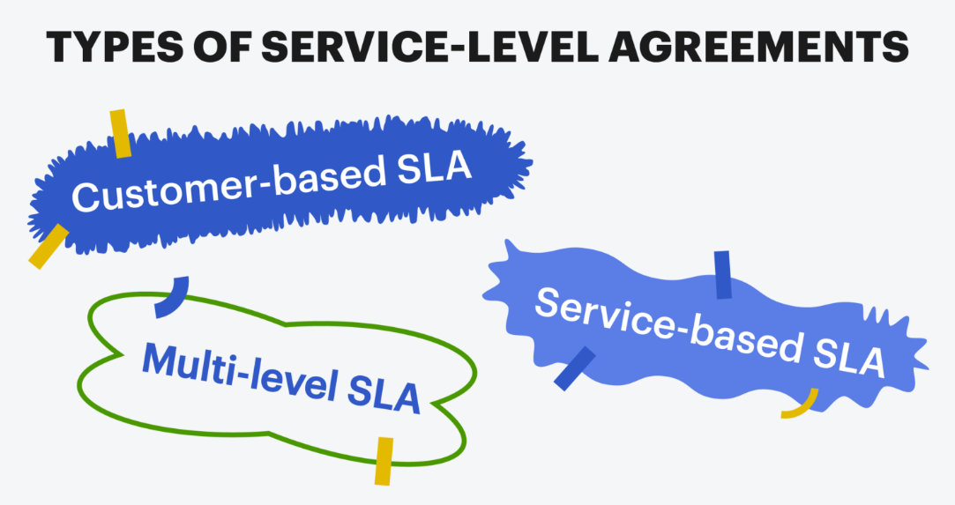

<https://www.groovehq.com/blog/what-is-sla-service-level-agreement>

1. Which of the following best describes the goal of Service Level Management?
   1. To maintain and improve IT service quality in line with business requirements
   2. To provide IT services at the lowest possible cost by agreeing with Customers their minimum requirements for service availability and ensuring performance does not exceed these targets
   3. To provide the highest possible level of service to Customers and continuously improve on this through ensuring all services operate at maximum availability
   4. To ensure that IT delivers the same standard of service at the least cost

Service Level Management is a formal way for setting customer expectations BEFORE the customer has the need to request service. It is a methodology for introducing and implementing reasonable expectations between you and the customers you support. These are most often contained in a document called a Service Level Agreement (SLA). The SLA establishes a two-way accountability for service, which is negotiated and mutually agreed upon. It is really a contract that documents operational and interpersonal relationships, establishes mutual expectations, and provides a standard to measure performance.

<https://www.giva.com.au/wp/implementing-service-level-agreements-it-service-desk.cfm>

1. The process to implement SLAs comprises of the following activities in sequence:
   1. Draft SLAs, catalogue services, review underpinning contracts and OLAs, draft SLRs, negotiate, agree

SLAs

* 1. Draft SLAs, review underpinning contracts and OLAs, negotiate, catalogue services,
  2. Review underpinning contracts and OLAs, draft SLAs, catalogue services, negotiate, agree SLAs
  3. Catalogue services, establish SLRs, review underpinning contracts and OLAs, negotiate service levels, agree SLAs

In the implementing agreements stage, the process is initiated with the business, operational level agreements (OLAs) and underpinning contracts (UCs) are validated, and service level agreements (SLAs) are defined and implemented.

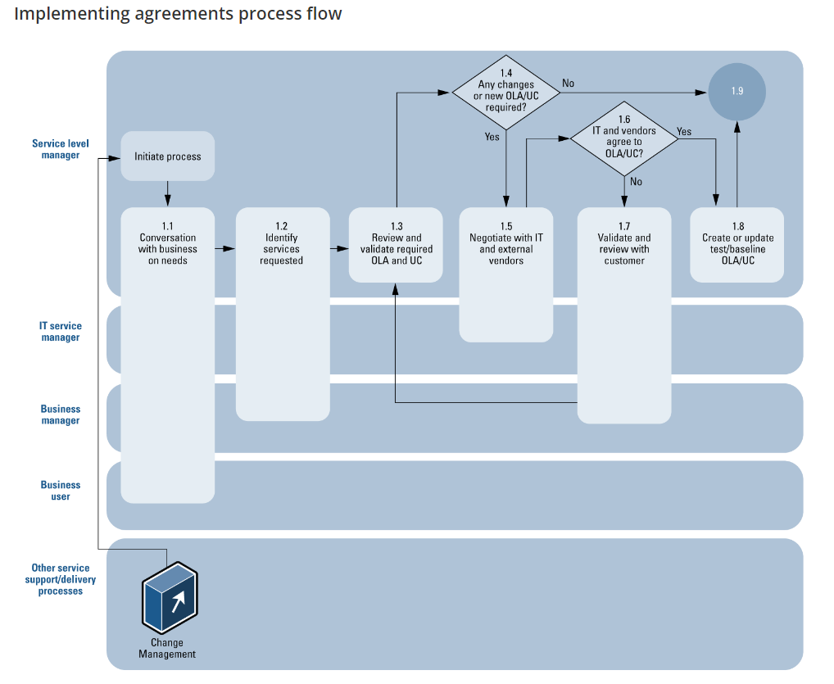

<https://docs.bmc.com/docs/slm1808/stage-1-implementing-agreements-821937306.html>

1. Which of the following is an example of a service level agreement (SLA) between an information systems support unit and a research unit in the laboratories of a large company?
   1. The maximum response time to get the system operational should it fail.
   2. The minimum ‘up-time’.
   3. The types of information that will be provided as standard.
   4. All of the above.

1. Some organisations bring a degree of formality to the internal customer concept by encouraging (or requiring) different parts of the operation to agree on:

a) Internal service agreements

* 1. Service level agreements
  2. Formal provision agreements
  3. Delivery agreements

# Search Index